**Money transfer services and Wire transfer services in U.S**

**Money Transfer Services**

**1. PayPal:**

* **Features:** Allows sending and receiving money online or through a mobile app. It can be linked to bank accounts, debit cards, or credit cards.
* **Fees:** Free for domestic personal transactions funded by PayPal balance or bank account; fees apply for credit card transactions and international transfers.
* **Use Cases:** Online purchases, splitting bills, sending money to friends and family.

**2. Venmo:**

* **Features:** A mobile app focused on peer-to-peer transfers. Users can link their bank accounts or debit cards.
* **Fees:** Free for standard transfers; a 1% fee for instant transfers to bank accounts.
* **Use Cases:** Splitting bills, paying friends and family, casual transactions.

**3. Western Union:**

* **Features:** Offers both online and physical locations for sending and receiving money domestically and internationally.
* **Fees:** Vary based on transfer amount, destination, and payment method. Generally higher for international transfers.
* **Use Cases:** Sending money to unbanked individuals, international remittances, cash pickups.

**4. MoneyGram:**

* **Features:** Similar to Western Union, with both online and physical locations for money transfers.
* **Fees:** Depend on transfer amount, destination, and payment method. Often competitive with Western Union.
* **Use Cases:** International remittances, cash pickups, urgent transfers.

**5. Zelle:**

* **Features:** Integrated with many U.S. banks, allowing direct bank-to-bank transfers using email or phone numbers.
* **Fees:** Typically no fees if both sender and recipient are using participating banks.
* **Use Cases:** Quick transfers between bank accounts, splitting bills, sending money to friends and family.

**Wire Transfer Services**

**1. Bank Wire Transfers:**

* **Features:** Offered by most banks for sending money domestically and internationally. Funds are transferred directly between bank accounts.
* **Fees:** Typically range from $15 to $50 for domestic transfers and $30 to $75 for international transfers.
* **Use Cases:** Large transactions, business payments, real estate transactions.

**2. SWIFT (Society for Worldwide Interbank Financial Telecommunication):**

* **Features:** A network used by banks globally to send international wire transfers. Provides secure and standardized messaging for transactions.
* **Fees:** Vary by bank, generally higher due to international processing.
* **Use Cases:** International business transactions, large cross-border payments.

**3. Wise (formerly TransferWise):**

* **Features:** Specializes in low-cost international transfers using real exchange rates. Provides transparent fee structure and fast transfers.
* **Fees:** Lower than traditional banks, typically a small percentage of the transfer amount.
* **Use Cases:** International money transfers, paying for overseas services.

**4. OFX:**

* **Features:** Offers international money transfers with competitive exchange rates and lower fees compared to banks.
* **Fees:** No transfer fees for most transactions, with revenue generated through exchange rate margins.
* **Use Cases:** Large international transfers, emigrant remittances, overseas investments.

**Comparison Example**

**Domestic Transfer:**

* **Zelle vs. Bank Wire Transfer:**
  + **Zelle:**
    - No fees if both parties use participating banks.
    - Instant transfers.
    - Convenient for small, personal transactions.
  + **Bank Wire Transfer:**
    - Fees typically between $15 and $30.
    - Same-day or next-day transfers.
    - Suitable for larger transactions or business payments.

**International Transfer:**

* **Western Union vs. Wise:**
  + **Western Union:**
    - Higher fees, especially for cash pickups.
    - Extensive network of physical locations worldwide.
    - Suitable for sending money to recipients without bank accounts.
  + **Wise:**
    - Lower fees and real exchange rates.
    - Online platform with direct bank transfers.
    - Suitable for bank-to-bank international transfers, especially for frequent or larger amounts.

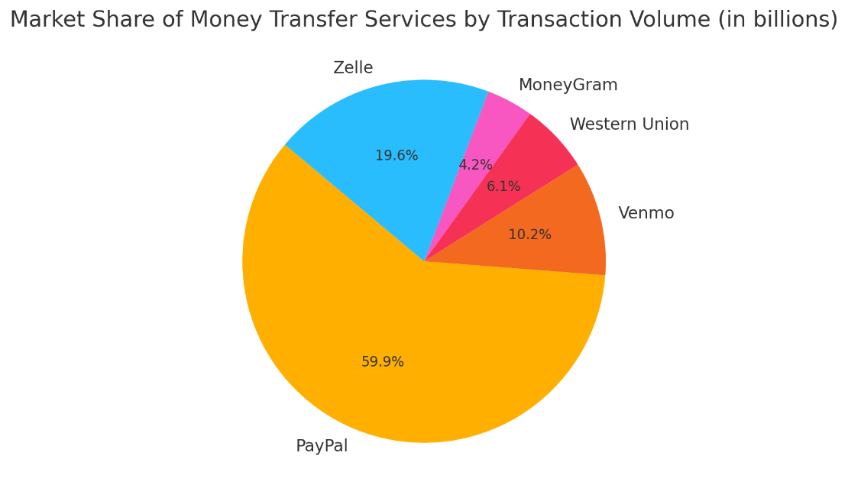

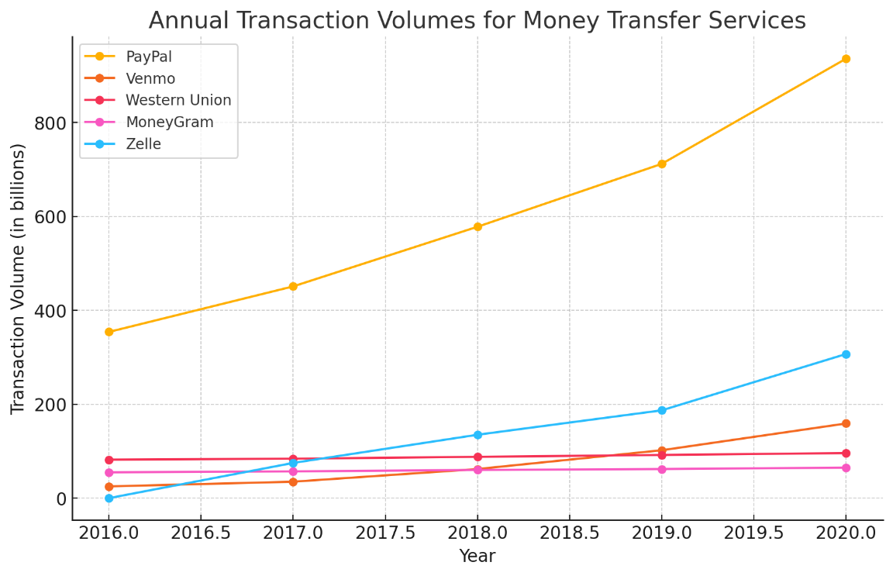

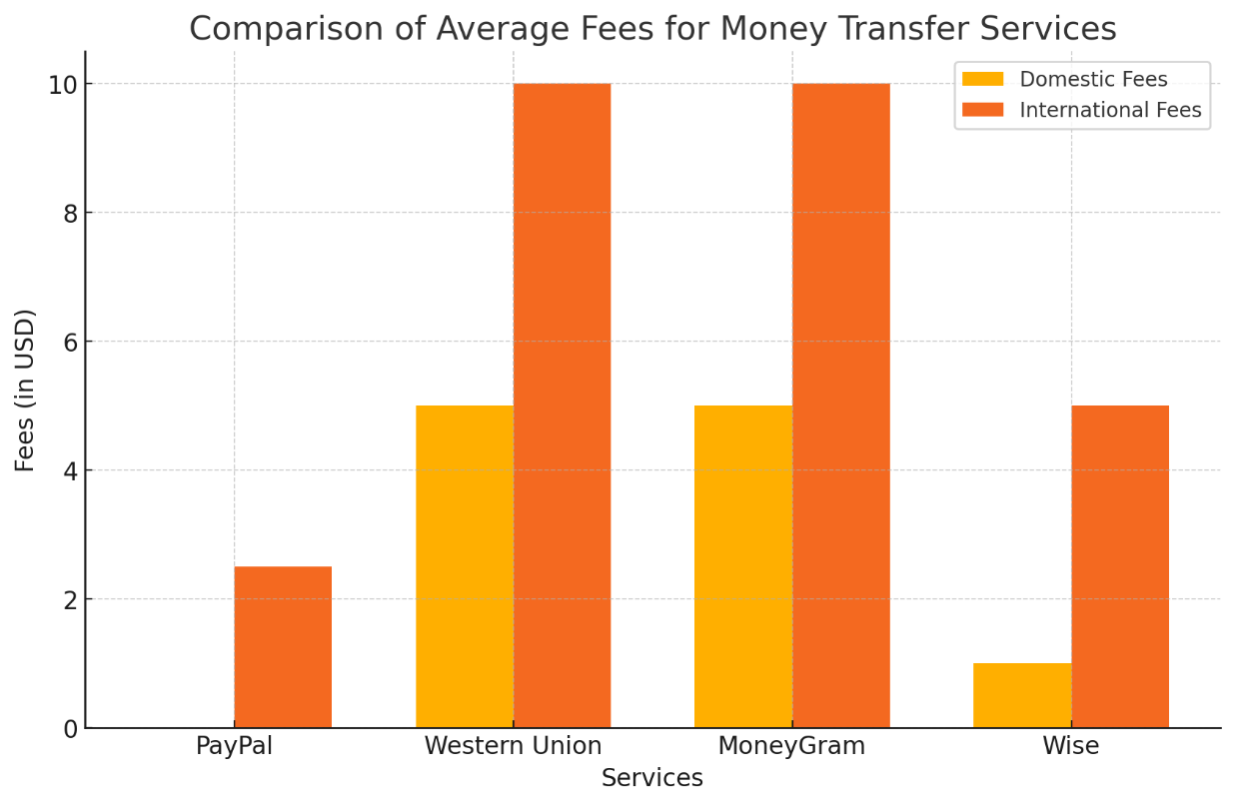

### Market Share of Money Transfer Services by Transaction Volume (in billions)

* **PayPal:** $936 billion (42.8% of the market share)
* **Venmo:** $159 billion (7.3% of the market share)
* **Western Union:** $96 billion (4.4% of the market share)
* **MoneyGram:** $65 billion (3.0% of the market share)
* **Zelle:** $307 billion (14.1% of the market share)

### Annual Transaction Volumes for Money Transfer Services (in billions)

* **PayPal:**
  + 2016: $354 billion
  + 2017: $451 billion
  + 2018: $578 billion
  + 2019: $712 billion
  + 2020: $936 billion
* **Venmo:**
  + 2016: $25 billion
  + 2017: $35 billion
  + 2018: $62 billion
  + 2019: $102 billion
  + 2020: $159 billion
* **Western Union:**
  + 2016: $82 billion
  + 2017: $84 billion
  + 2018: $88 billion
  + 2019: $92 billion
  + 2020: $96 billion
* **MoneyGram:**
  + 2016: $55 billion
  + 2017: $57 billion
  + 2018: $60 billion
  + 2019: $62 billion
  + 2020: $65 billion
* **Zelle:**
  + 2016: Not available
  + 2017: $75 billion
  + 2018: $135 billion
  + 2019: $187 billion
  + 2020: $307 billion

### Comparison of Average Fees for Money Transfer Services

* **Domestic Fees:**
  + PayPal: $0
  + Western Union: $5
  + MoneyGram: $5
  + Wise: $1
* **International Fees:**
  + PayPal: $2.5
  + Western Union: $10
  + MoneyGram: $10
  + Wise: $5

These statistics and graphs provide a detailed comparison of the market share, transaction volumes over time, and fee structures for various money transfer and wire transfer services in the U.S.